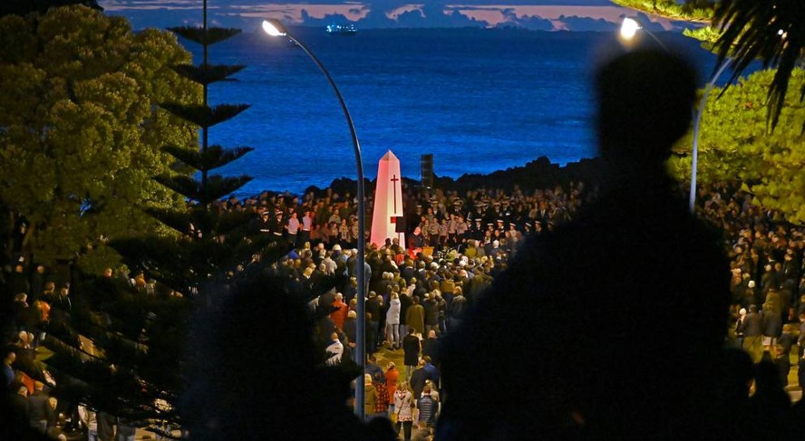

Anzac Day 2021
The following speech was presented by the Mount Maunganui RSA President Arthur King
Veterans, distinguished guests from New Zealand and Australia, ladies, gentlemen, children.
As president of the Mount Maunganui RSA, it is my privilege to welcome you for our commemoration of Anzac Day 2021.

The last 12 months have been extremely challenging for all of us, we are now most fortunate to be able to stand here and enjoy our time together.

Emily Tattersall from the Mount Maunganui College sang the first verse of the Australian National anthem followed by the New Zealand National anthem in Maori and English.

The Mount Maunganui RSA chaplain reverend Marie Gilpin then leads us in the opening prayer.

This morning we join together to remember and honour the young men and women who served our country in two world wars and other conflicts throughout the globe and those who continue to serve our New Zealand defence forces both at home and abroad.

This year marks the 175th anniversary of the formation of the New Zealand army, we remember the 507 who died while training in New Zealand between 1914 to 1918.

105 years ago, the first Anzacs landed at Gallipoli, through their tenacity, bravery, and suffering gained the legendary reputation that Anzacs still retain to this day.

In November, at 11am on the 11th of the 11th will mark 107 years since Armistice Day after 16,697 New Zealanders were killed, 41,317 were wounded, and a further thousand men who died within five years of the wars end because of injuries sustained.

This year also marks the 105th Anniversary of the formation of the New Zealand Returned and Services Association

The word Passchendaele has become synonymous with battles fought, battles lost, lives lost, and encompasses the horrors of war. by the time, our troops finally withdrew from the Flanders frontline New Zealand had suffered more than 18,000 casualties including around 5000 deaths.

We at the Mount Maunganui RSA are proud to be the headquarters of the New Zealand battle of Crete Association this year being the 80th anniversary of the battle in May 1941 we still have soldiers over the age of 100 joining us for services

Within the Mount Maunganui RSA J force meetings are still held regularly, this year members were flown to Wellington to the government house for a presentation.
In 2020 the Mount Maunganui RSA assisted in sponsoring the 65th anniversary reunion of the New Zealand special and service squadron who in 1955 as a New Zealand contribution to the British Commonwealth far east strategic reserve operated with the British 22nd regiment in Malaya against the Communist Terrorists until 1957.

Yesterday we hosted riders for the ride of remembrance who over the last few weeks have been continuously showing their support throughout New Zealand.
Whilst we may cheekily refer to them as boys with their toys, we must remember that a number of the riders are members of the Patriots motorcycle club some are either serving still or have served with some still involved in training soldiers to serve overseas.

The Mount Maunganui RSA is proud to be the headquarters of the Hauraki branch of the Patriots DFMCS (the defence force motorcycle club).

Whilst we reflect on past conflicts where the Mount Maunganui RSA is proud to sustain the RSA movement, we also are thinking forward to encourage everyone Returned service or non-service to enjoy our facilities and camaraderie.

All RSAs throughout New Zealand are now a place not only for returned and service but for families to enjoy a safe and welcoming atmosphere.

Benediction Marie Gilpin

